|  |
| --- |
| BLUEsat UNSW Student Satellite Project  Document BLUE.2011.3.0 |
| Battery Charge Regulator |
| Progress Report Aug 2012 |
| **Authors and Contributors:**  Thomas Fisk  Chris Brown Mitch Wenke  **Date:** |
| August 11, 2012 |

# Introduction

The BLUEsat Battery Charge Regulator (BCR) is a key component of the satellite bus that has been designed from scratch by our Power Team. It features six redundant battery chargers which allow independent peak power point tracking for the satellite’s six solar panels.

We have proven our design and are currently on our 3rd PCB revision, finalising software for the independent BCR microcontroller.

# Table of Contents

1 Introduction 1

2 Table of Contents 1

3 New Specifications 2

4 Current Development Board 3

5 Future Work 4

6 Conclusion 5

# New Specifications

PV cell voltage

Battery voltage

Switching frequency

# Current Progress

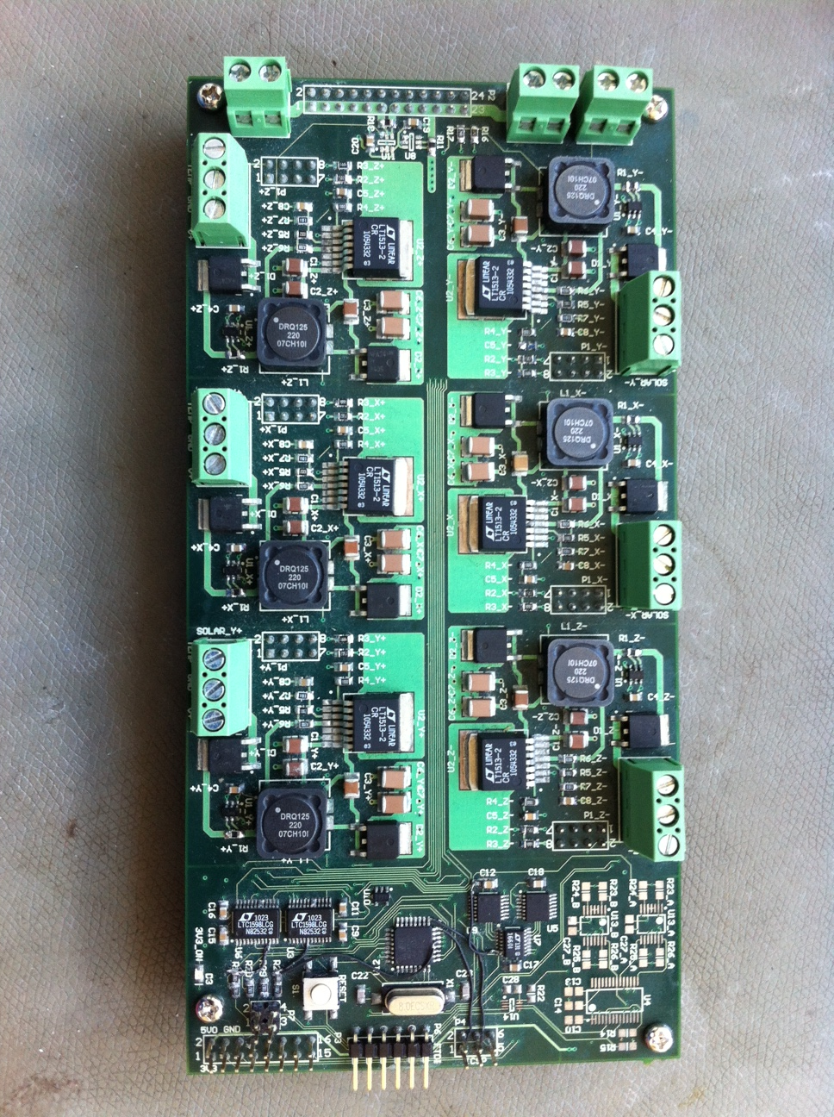

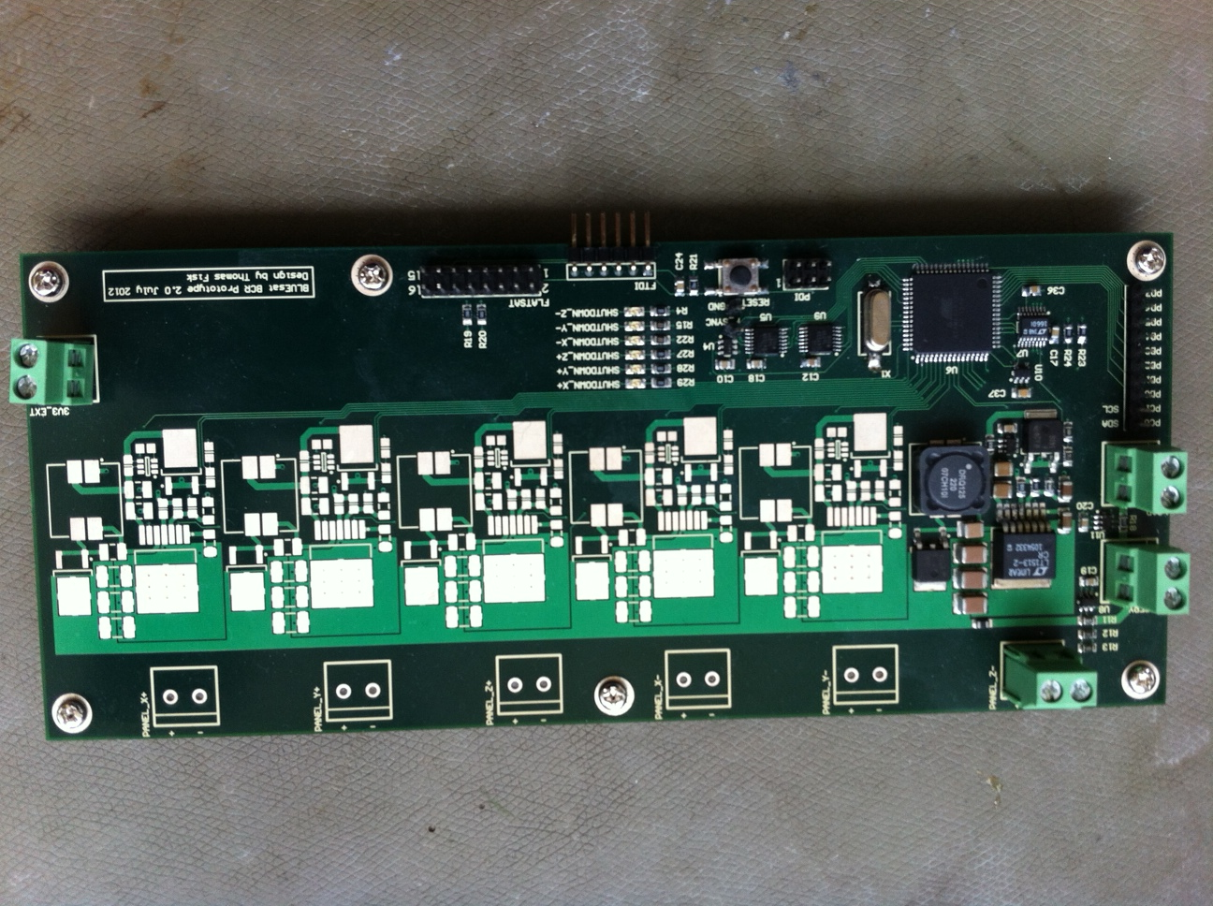

See schematics

# Future Work

# Conclusion